**10 SCIENCE**

### PHYSICS TEST

Name: ____________________ Teacher: ___________________ Mark: /45

**Percentage %**

**SECTION A: MULTIPLE CHOICE (20 marks)**

**Please answer on the multiple choice answer grid sheet on *page 4.***

**1.** Below are two pieces of ticker timer tape. Choose the correct statement.

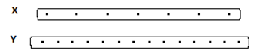

(a) The object pulling ticker timer tape ‘X’ was accelerating.

(b) The object pulling ticker timer tape ‘Y’ was accelerating.

(c) The object pulling ticker time tape ‘Y’ was moving faster than the object pulling ticker timer tape ‘X’.

(d) The object pulling ticker time tape ‘X’ was moving faster than the object pulling ticker timer tape ‘Y’.

**2.** Below is a piece of ticker timer tape. Choose the correct statement.

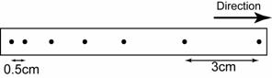

(a) The object pulling the ticker timer tape was accelerating.

(b) The object pulling the ticker timer tape was decelerating.

(c) The object pulling the ticker timer tape was moving at a constant speed.

(d) The object pulling the ticker timer tape was not moving.

**3.** State which unit(s) could be used to measure speed.

(a) Year per metre.

(b) Millimetre per second

(c) Kilometre per hour

(d) (b) and (c).

**4.** Look at the data in this table.

|  |  |
| --- | --- |
| Type of car | Time taken to reach 100km/h from rest (minutes) |
| Ariel Atom V8 | 2.5 |
| Nissan GTR | 3 |
| [Lamborghini Aventador](http://news.drive.com.au/drive/motor-news/first-drive-lamborghini-aventador-20110602-1fhci.html) | 2.9 |

Of the cars in the table above which has the fastest acceleration?

(a) Ariel Atom V8.

(b) Nissan GTR.

(c) Lamborghini Aventador.

(d) This question cannot be answered with the information in the table.

**5.** The two components of total stopping distance for are car are.

(a) Acceleration and reaction time.

(b) Reaction distance and braking distance.

(c) Acceleration and deceleration.

(d) The overall distance travelled from start to the end of the journey.

**6.** Choose the correct definition for ‘distance’.

(a) A straight-line distance between the finishing and starting points.

(b) A measurement of the direction an object is in.

(c) A straight-line distance and direction between the finishing and starting points.

(d) A measurement of how far away objects are.

**7.** Choose the correct definition for ‘displacement’.

(a) A straight-line distance and direction between the finishing and starting points.

(b) A measurement of how far away objects are.

(c) A straight-line distance between the finishing and starting points.

(d) A measurement of the direction an object is in.

**8.** Choose the correct definition for ‘reaction time’.

(a) The time taken for the brakes of a car to take effect.

(b) The distance taken for a cars brakes to take effect.

(c) The time taken for a hazard to occur.

(d) The length of time it takes a driver to respond to a hazard.

**9.** Choose the correct definition for ‘reaction distance’.

(a) The length of time it takes a driver to respond to a hazard.

(b) Distance moved while reacting to an emergency.

(c) The time taken for a hazard to occur.

(d) Both (a) and (b).

**10.** Shelly was testing which fertilizer made his roses grow the fastest. He gave 5 roses 100g of the fertiliser and 5 other roses of the same type no fertiliser. He measured how fast the roses grew. In the experiment the independent variable is:

(a) The type of roses

(b) Fertiliser or no fertiliser.

(c) The speed at which the roses grew.

(d) The mass of the roses.

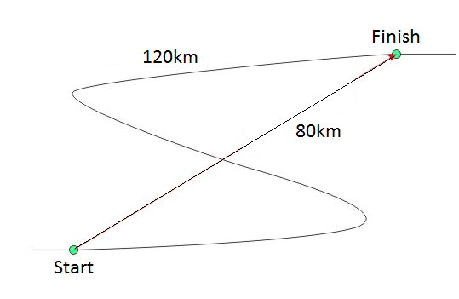

*Question* ***11,******12*** *and* ***13*** *refers to the diagram on the right.*

**11.** The distance travelled is:

(a) 120km.

(b) 40km.

(c) 80km.

(d) 200km.

**12.** The displacement travelled is:

(a) 40km North East.

(b) 80km South East.

(c) 40km South East

(d) 80km North East.

**13.** Choose the correct statement below.

(a) The distance is greater than the displacement.

(b) The displacement is greater than the distance.

(c) The distance and displacement are the same.

(d) The displacement is sometimes a straight line distance and direction.

**14.** A handheld speed camera is used to measure:

[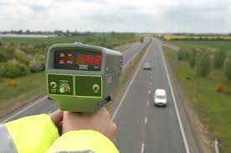](http://www.google.com.au/imgres?imgurl=http://www.marymonson.co.uk/wp-content/uploads/2013/10/iStock_000003366366Small.jpg&imgrefurl=http://www.marymonson.co.uk/useful-information/types-of-speed-cameras/&h=564&w=851&tbnid=F9ajRifIK3C5KM:&zoom=1&q=handheld%20speed%20camera&docid=Sh4zHLA5CTzBBM&ei=ipmnU_XMEpS78gW82oLoDg&tbm=isch&ved=0CDwQMygYMBg&iact=rc&uact=3&dur=1104&page=1&start=0&ndsp=43)

(a) Instantaneous speed of a vehicle.

(b) Average speed of a vehicle.

(c) Acceleration of a vehicle.

(d) Velocity of a vehicle.

**15.** The friction between the air and a falling object is called:

(a) Friction.

(b) Air resistance.

(c) Gravitational pull.

(d) Gravity resistance.

**16.** Choose the correct definition for ‘terminal velocity’.

(a) The final velocity the object has when it can accelerate further.

(b) The rate at which displacement changes.

(c) The final velocity the object has when it falls with no further acceleration possible.

(d) The rate at which average speed changes.

**17.** Acceleration due to gravity is:

(a) 9.8m/s2

(b) 9m/s

(c) 9m/s2

(d) 9.8m/s

**18.** Choose the correct definition for ‘velocity’.

(a) The rate at which displacement changes.

(b) The rate at which speed changes.

(c) The rate at which direction changes.

(d) The rate at which average speed changes.

**19.** Choose the correct definition for ‘instantaneous speed’.

(a) The rate at which average speed changes

(b) The speed of an object at a particular moment.

(c) The rate at which average speed changes.

(d) The speed of an object over time.

**20.** Choose the correct definition for ‘acceleration’.

(a) The rate at which average speed changes.

(b) The rate of change of acceleration.

(c) The rate of change of velocity.

(d) The rate at which direction changes.

**Physics Test**

Name: ________________________ Teacher: ___________________ Mark: /45

**Percentage %**

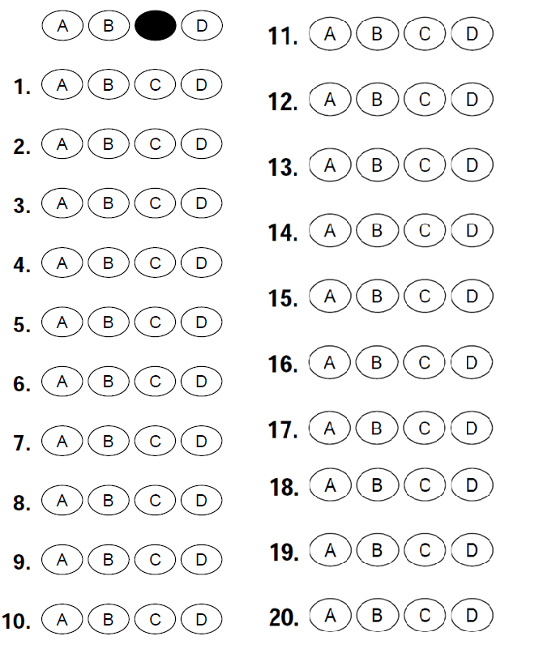

**SECTION B: SHORT ANSWER (25 marks)**

**1.** State whether displacement a scalar quantity or a vector quantity and explain why. (2 marks)

______________________________________________________________________________________

______________________________________________________________________________________

______________________________________________________________________________________

**2.** State whether distance a scalar quantity or a vector quantity and explain why. (2 marks)

______________________________________________________________________________________

______________________________________________________________________________________

______________________________________________________________________________________

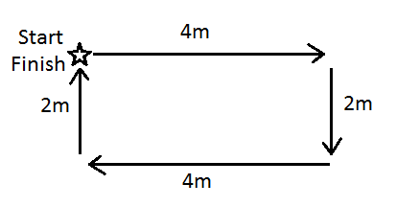**3.** Mr Lafferty walked around the park as shown in the diagram below.

a) Calculate Mr Lafferty’s distance. (1 mark)

______________________________________________________________________________________

b) Calculate Mr Lafferty’s displacement. (1 mark)

______________________________________________________________________________________

**4.** Explain why humans are better at tolerating horizontal forces compared with vertical forces. (2 marks)

______________________________________________________________________________________

______________________________________________________________________________________

______________________________________________________________________________________

______________________________________________________________________________________

**5.** Jade rides her bike with a constant speed of 7m/s. It takes 4 minutes to get to school. Calculate how far away school is. (2 marks)

**SHOW ALL OF YOUR WORKING OUT.**

Distance= average speed x time d = v x t

d= v= t=

**6.** Aluet drives her car with a constant speed of 40m/s for 480 seconds to work. Calculate how far away work is. (2 marks)

**SHOW ALL OF YOUR WORKING OUT.**

Distance= average speed x time d = v x t

d= v= t=

**7.** Shania drives her car with a constant speed of 20m/s and takes 0.5 seconds to react and apply the brakes when she sees a cat on the road. Calculate the distance she travels before hitting the brakes. **SHOW ALL OF YOUR WORKING OUT.** (2 marks)

Distance= average speed x time d = v x t

d= v= t=

**8.** A car speeds up to 70km/h from rest in 6 seconds. Calculate its average acceleration.

**SHOW ALL OF YOUR WORKING OUT.** (2 marks)

Average acceleration = change in speed a = v-u

Time t

a = v = u = t =

**9.** A car initially travelling at 35km/h accelerates at a constant rate of 3km/h/s for 40 seconds. Calculate its final speed.

**SHOW ALL OF YOUR WORKING OUT.** (2 marks)

Final speed = initial speed + average acceleration x time v = u + at

a = v = u = t =

**10.** A car initially travelling at 50km/h accelerates at a constant rate of 4km/h/s for 30 seconds. Calculate its final speed.

**SHOW ALL OF YOUR WORKING OUT.** (2 marks)

Final speed = initial speed + average acceleration x time v = u + at

a = v = u = t =

**11.** This table shows the speed of a man driving a car over time.

|  |  |
| --- | --- |
| **Speed of car (m/s)** | **Time (s)** |
| 5 | 2 |
| 30 | 4 |
| 28 | 6 |
| 10 | 8 |
| 5 | 10 |

Draw a graph using the information from the table above. (5 marks)

Don’t forget all the things that a graph needs!

[](http://www.google.com.au/url?sa=i&rct=j&q=graph+paper&source=images&cd=&cad=rja&uact=8&docid=bnDyK-WDEHhooM&tbnid=OH_xw5ZTcFEuvM:&ved=0CAUQjRw&url=http://virtualmathtutor.blogspot.com/2010/11/how-to-draw-circle-without-compass.html&ei=RKw4U5fxF8fClQWCrIGoCQ&psig=AFQjCNHahbsWAgdANQM5RZCXw4z48cLLBw&ust=1396309252654415)